Lab No 4

Question 1
Create a query to display the employee name and the name of the department for each employee in UPPERCASE.
Make sure all other columns retain their original case formatting.
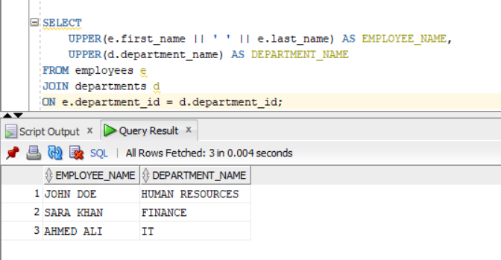

Question 2
Create a query to find the length of each employee's last name. Display the results in three columns:
- First Name
- First letter of Last Name
- Length of the employee’s Last Name
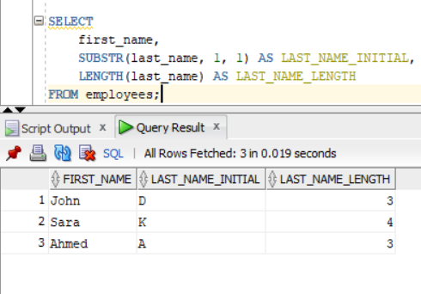

Question 3
Write a query to display employee names along with the length of their full names.
Also concatenate the results in the format:
“John Doe [7]”
Label the column as Full Name Length
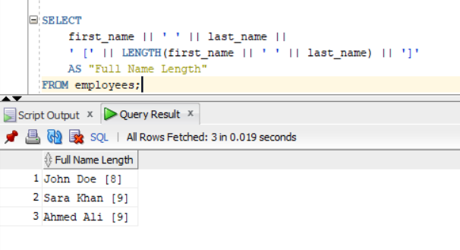

Question 4
Extract the first 3 characters of each employee’s first name.
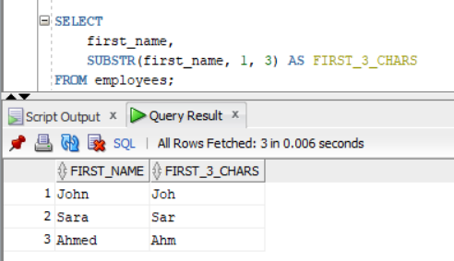

Question 5
Write a query to display product names and rounded product prices to nearest integer, ordered by rounded price in descending order.
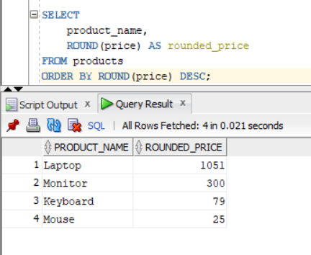

Question 6
Display product prices rounded to the nearest tens place.
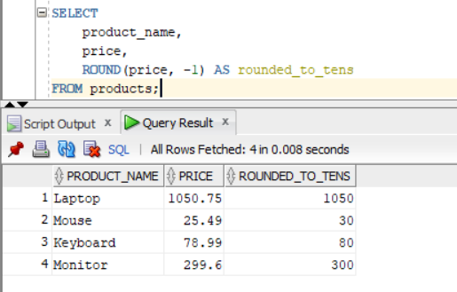

Question 7
Find the remainder when product price is divided by 5.
Display:
- Rounded price
- Truncated price
Label columns as:
- ROUNDED_PRICE
- TRUNCATED_PRICE
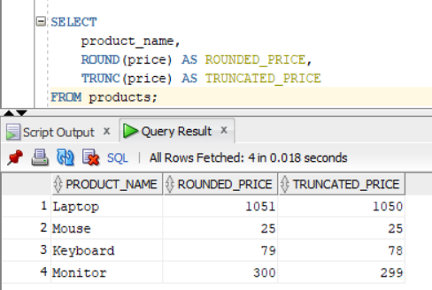

Question 8
Display the order date truncated to the start of the month.
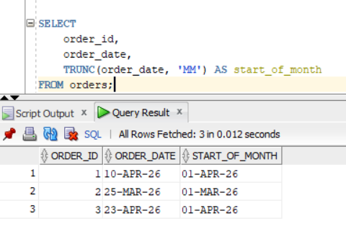

Question 9
Concatenate employee name and rounded salary to nearest 100.
Display result in format:
“Doe, John | Salary 2000”
Label column as EMP_PAY_DETAILS

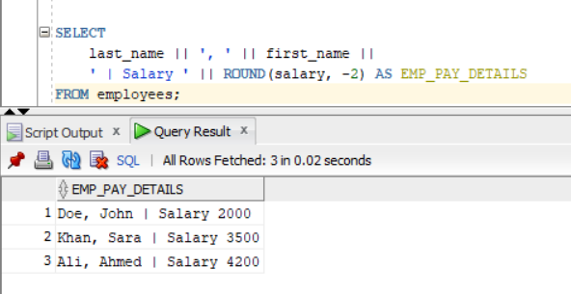

Question 10
Write a query to find employees where the length of first name is greater than 5.
Label the column as NAME_LENGTH_FILTER
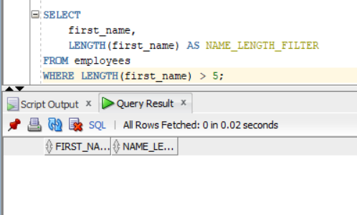

Question 11
Write a query to display employee names justified in the middle of a fixed width column using LPAD and RPAD.
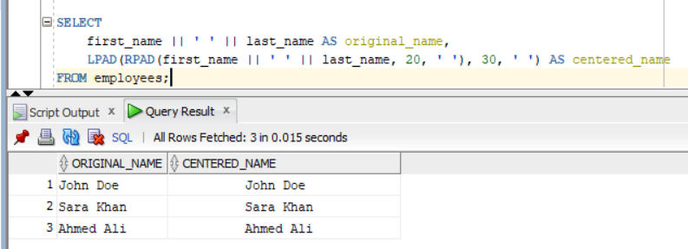

Question 12

Write the differences between ROUND and TRUNC. OR Write the differences between INSTR and SUBSTR.

Difference between ROUND and TRUNC
ROUND and TRUNC are both used for working with numbers in Oracle, but they behave differently.
ROUND is used to round a number to the nearest value based on normal mathematical rules. If the digit after the rounding point is 5 or more, it increases the value, otherwise it keeps it the same. For example, ROUND(78.6) becomes 79 and ROUND(78.4) becomes 78.
TRUNC, on the other hand, simply removes the decimal part without rounding. It does not consider the value after the decimal point. For example, TRUNC(78.6) becomes 78 and TRUNC(78.9) also becomes 78.
So, the main difference is that ROUND adjusts the value based on rules, while TRUNC just cuts off the decimal part without any rounding.

Difference between INSTR and SUBSTR
INSTR and SUBSTR are both string functions in Oracle, but they are used for different purposes.
INSTR is used to find the position of a character or substring inside a string. It returns a numeric value showing where the character is located. For example, INSTR('John Doe', 'D') returns 6 because 'D' starts at position 6.
SUBSTR is used to extract a part of a string from a given position. It returns the actual text instead of the position. For example, SUBSTR('John Doe', 1, 4) returns 'John'.
So, the main difference is that INSTR tells the position of a character, while SUBSTR extracts a portion of the string.

